|  |  |
| --- | --- |
| LIFE logo | **HOLY CROSS COLLEGE**  **SEMESTER 1, 2019**  **Question/Answer Booklet** |

Please place your student identification label in this box

12 PHYSICS

Student Name ___________________________________

Student’s Teacher __________________________________________

#### Time allowed for this paper

Reading time before commencing work: 10 minutes

Working time for paper: 3 hours

**Materials required/recommended for this paper**

**To be provided by the supervisor**

This Question/Answer Booklet

Multiple-choice Answer Sheet

Data Sheet

***To be provided by the candidate***

Standard items: pens, pencils, eraser, correction fluid, ruler, highlighters

Special items: non-programmable calculators satisfying the conditions set by the School Curriculum and Standards Authority for this course

**Important note to candidates**

No other items may be taken into the examination room. It is **your** responsibility to ensure that you do not have any unauthorised notes or other items of a non‑personal nature in the examination room. If you have any unauthorised material with you, hand it to the supervisor **before** reading any further.

**Structure of this paper**

|  |  |  |  |  |  |
| --- | --- | --- | --- | --- | --- |
| Section | Number of questions available | Number of questions to be answered | Suggested working time  (minutes) | Marks available | Percentage of exam |
| Section One:  Short Answers | 16 | 16 | 50 | 58 | 33 |
| Section Two:  Problem-solving | 6 | 6 | 90 | 78 | 44 |
| Section Three:  Comprehension | 2 | 2 | 40 | 40 | 23 |
|  | | | | 176 | 100 |

**Instructions to candidates**

1. The rules for the conduct of examinations at Holy Cross College are detailed in the College Examination Policy*.* Sitting this examination implies that you agree to abide by these rules.

2. Write your answers in this Question/Answer Booklet.

3. Working or reasoning should be clearly shown when calculating or estimating answers.

4. You must be careful to confine your responses to the specific questions asked and to follow any instructions that are specific to a particular question.

5. Spare pages are included at the end of this booklet. They can be used for planning your

responses and/or as additional space if required to continue an answer.

• Planning: If you use the spare pages for planning, indicate this clearly at the top of the

page.

• Continuing an answer: If you need to use the space to continue an answer, indicate in

the original answer space where the answer is continued, i.e. give the page number.

Fill in the number of the question(s) that you are continuing to answer at the top of the

page.

6. Answers to questions involving calculations should be ***evaluated and given in decimal***

***form*.** It is suggested that you quote all answers to ***three significant figures***, with the

exception of questions for which estimates are required. Despite an incorrect final result,

credit may be obtained for method and working, providing these are ***clearly and legibly set***

***out***.

7. Questions containing the instruction *"****estimate****"* may give insufficient numerical data for their

solution. Students should provide appropriate figures to enable an approximate solution to

be obtained. Give final answers to a maximum of ***two significant figures*** and include appropriate units where applicable.

8. Note that when an answer is a vector quantity, it must be given with magnitude and direction.

9. In all calculations, units must be consistent throughout your working.

**Section One: Short response 30% (58 Marks)**

This section has **16** questions. Answer **all** questions.

Suggested working time: 50 minutes.

**Question 1 (5 marks)**

****A ball is thrown from *S* at an angle to the horizontal as shown in the diagram below. *X*, *Y*, and *Z* are different positions along the ball’s trajectory.

(a) On the diagram above, label each position (X, Y and Z) with an arrow that best represents the velocity and the acceleration of the ball, at that time. (3 marks)

(b) The trajectory shown above assumes that the ball is not affected by air resistance. Draw the trajectory of the ball if air resistance is present. (2 marks)

**Question 2 (4 marks)**



In a movie, the stunt men drove their car across a horizontal car park in building 1 and landed it in the car park of building 2, one floor lower. Building 2 is 20.0 m from building 1, as shown in the figure above. The floor where the car lands in building 2 is 4.00 m below the floor from which it started in building 1.

Calculate the minimum speed at which the car should leave building 1 in order to land in the car park of building 2, if the effect of air resistance is ignored.

Ian Wilson

<http://www.schoolphysics.co.uk/age16-19/Mechanics/Circular%20motion/text/Circular_Motion2/index.html>

**Question 3 (4 marks)**

A toy slot car set has a horizontal circular track as shown in the diagram opposite.

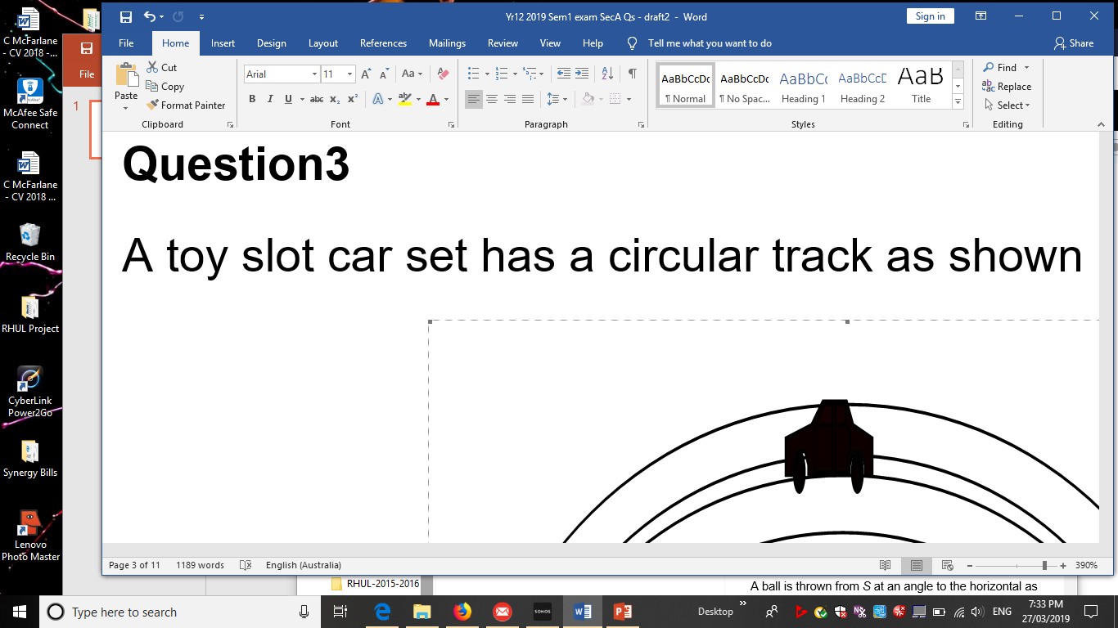

(a) On the diagram, show the direction of the nett (unbalanced) force acting on the slot car.

(b) The diagram is drawn one-tenth full size. The mass of the slot car is 0.250 kg and the nett force is 3.25 N**, *estimate*** the speed of the car.

**Question 4 (4 marks)**

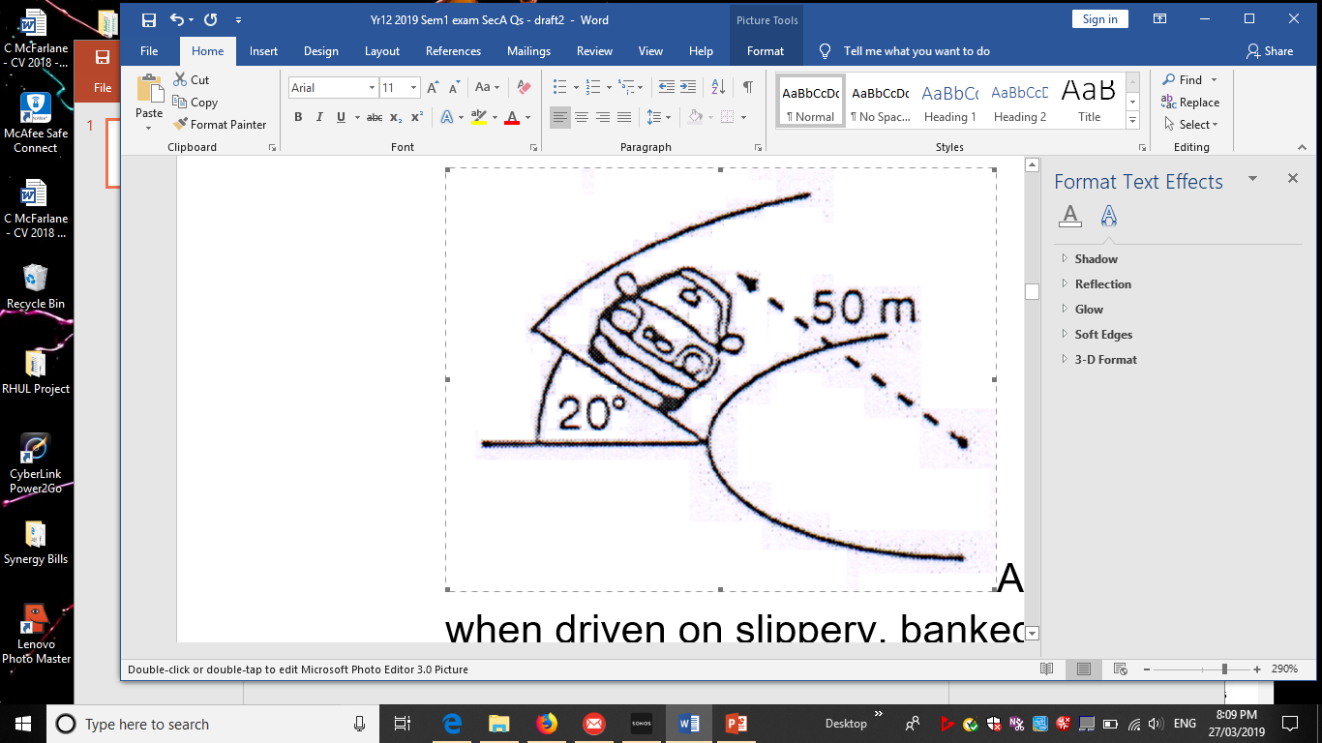

A new car is being test driven to determine how it performs when driven on slippery, banked surfaces. The car has a mass of 1.20 tonne and is driven around a 20.0° banked curve, which has a radius of 50.0 m.

(a) ***Derive the formula*** that indicates the maximum speed the car can drive around the curve without slipping. (2 marks)

(b) Use this formula to ***calculate the maximum speed*** of the car without slipping as it drives around the curve. (2 marks)

**Question 5 (4 marks)**

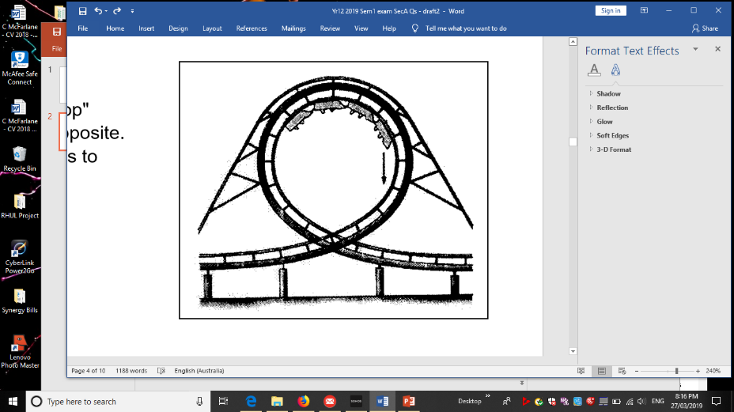

A thrill seeker is persuaded to go on a "loop the loop" amusement ride similar to the one in the picture opposite. The circular loop has a diameter of 18.0 m and it takes 4.70 s to complete one loop.

(a) Calculate the centripetal acceleration of a 40.0 kg rider.

(3 marks)

(b) Is the centripetal acceleration for a 50.0 kg rider the same, increased or decreased? (1 mark)

Answer: ______________

**Question 6 (4 marks)**



The diagrams show a communications satellite in orbit about the Earth.

(a) Which diagram correctly represents the ***nett force F*** acting on the satellite and the ***velocity v*** of the satellite?

Answer: _________

(b) Explain why domestic satellite dishes for pay-TV do not ‘track’ across the sky

(i.e. they don’t move), although the satellites that they receive their signals from are in constant motion.

**Question 7 (4 marks**)

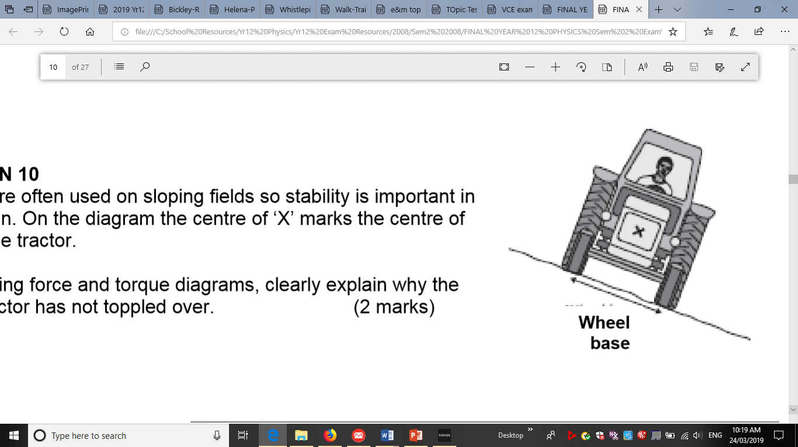

Tractors are often used on sloping fields so stability is important in their design. On the diagram, ***X*** marks the centre of mass of the tractor.

(a) Using force and torque diagrams, clearly explain why the tractor has not toppled over. (2 marks)

(b) State how the design of the tractor could be modified to increase the tractor’s stability.

(2 marks)

**Question 8 (3 marks)**

The figure shows an overhead view (birds-eye view) of a metal square lying flat on a frictionless floor. Three forces, which are drawn to scale, act at the corners of the square. **Circle** the correct answer.

(a) Is the square in translational equilibrium?

YES NO

(b) Is the square in rotational equilibrium?

YES NO

(c) Is it possible for a fourth force to act on the fourth corner of the square such that the square is in static equilibrium?

YES NO

**Question 9 (4 marks)**



The bridge in the diagram can be considered as a uniform concrete beam of length 30.0 m and mass 20.0 tonnes. A heavily loaded small truck of mass 6.00 tonnes is pictured crossing the bridge.

Calculate the magnitude of each of the normal contact forces N1 (Fn1) and N2 (Fn2) at each end of the bridge when the centre of mass of the truck is 10.0 m from one end.

**Question 10 (1 mark)**

Three identical wires W1, W2 and W3 are positions as shown. Each carries a current of the same magnitude in the direction indicted.

What is the magnitude and direction of the resultant force on W2? ***Circle*** the correct answer

(A, B, C, D) .

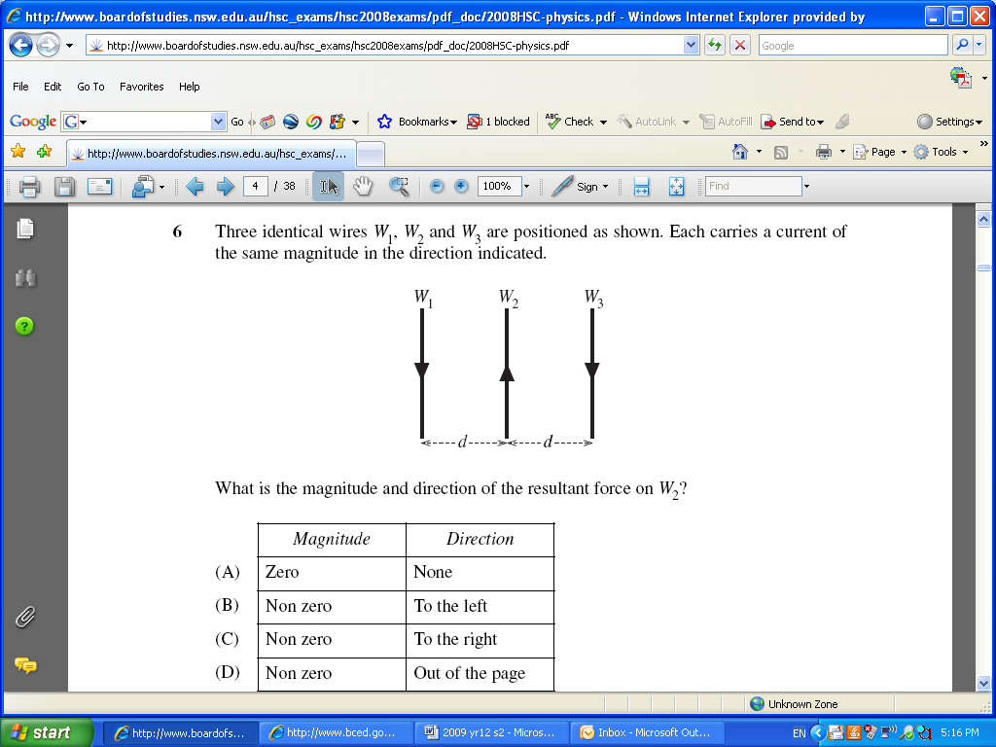



**Question 11 (1 mark)**

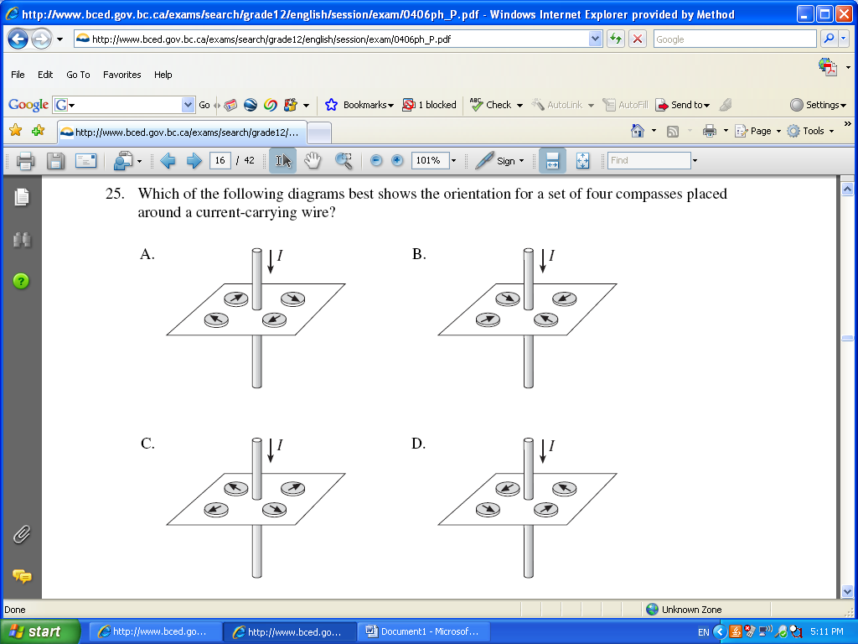

Which of the following diagrams best shows the orientation for a set of four compasses placed around a current-carrying wire?

Answer: **_______**

**Question 12 (4 marks)**

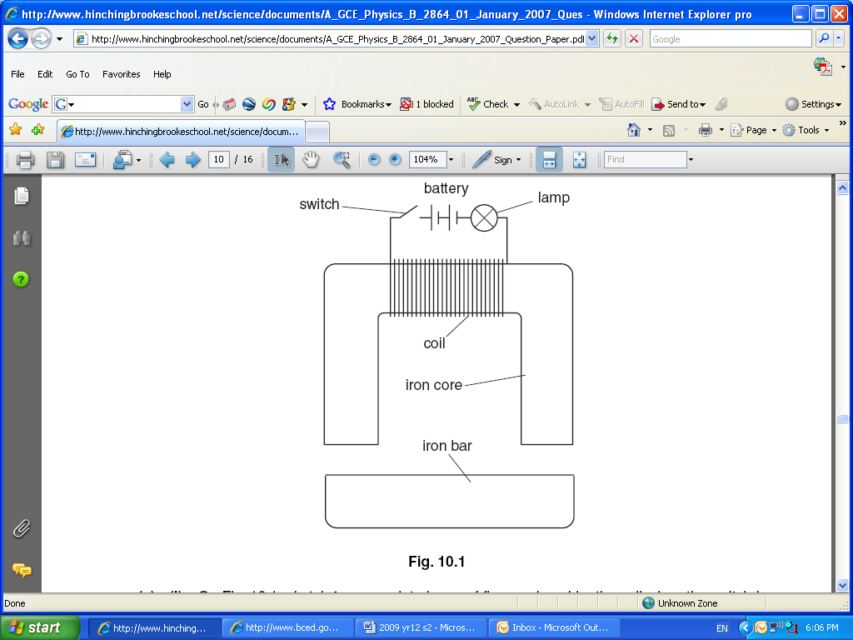

This question is about using an electromagnet to lift a heavy load.

The figure shows a coil of insulated wire wrapped around the centre of an iron core. An iron bar is pulled up to the core when the switch is closed. The lamp glows when there is current in the coil.

(a)On the diagram, sketch ***two complete loops*** of flux produced by the coil when the switch is closed. (2 marks)

(b)Use ideas of magnetic flux to explain why the iron bar is pulled up to the iron core when the switch is closed. (2 marks)

**Question 13 (4 marks)**

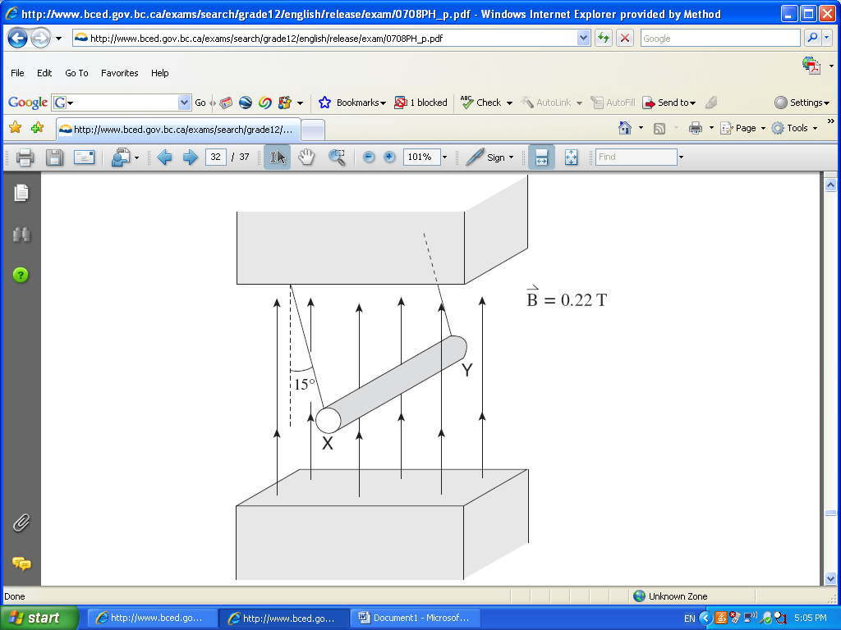

An 18.0 cm long metal rod of mass 35.0 g is suspended from the ceiling with a light wire of negligible mass. A uniform 0.220 T magnetic field is directed vertically upward.

When there is a current in the rod, it swings outward 15.0° to the vertical as shown in the figure opposite.

1. What is the direction of the current in the rod? ***Circle*** the correct response. (1 mark)

X to Y Y to X No current

1. Calculate the magnitude of the current in the rod. (3 marks)

Answer ___________________________

**Question 14 (3 marks)**

A beta particle travels at a speed of 3.90 x103 km h-1 while following a circular path of radius

0.0200 m perpendicular to a magnetic field. Calculate the strength of the magnetic field. Show all working.

Answer: ____________

**Question 15 (3 marks)**

An electric motor is set up as shown in the diagram below. When the current is supplied, the coil does not turn. Which of the following is required for the coil to start turning?

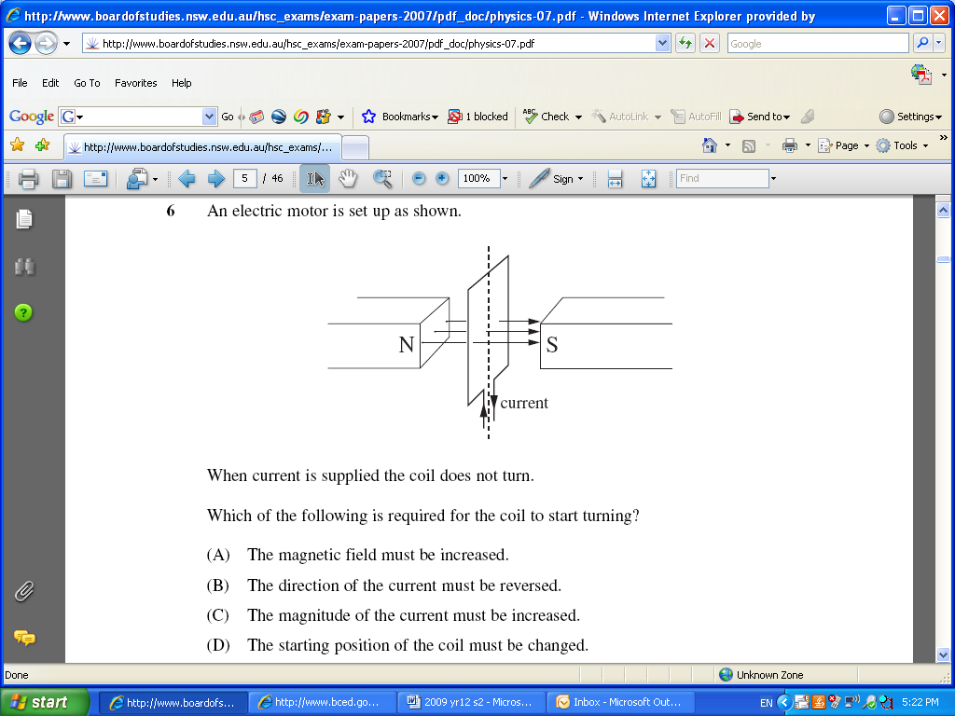

(a) The magnetic field must be increased.

(b) The direction of the current must be reversed.

(c) The magnitude of the current must be increased.

(d) The starting position of the coil must be changed.

Answer:

Briefly explain what needs to change to allow the coil to start turning.

**Question 16 (6 marks)**

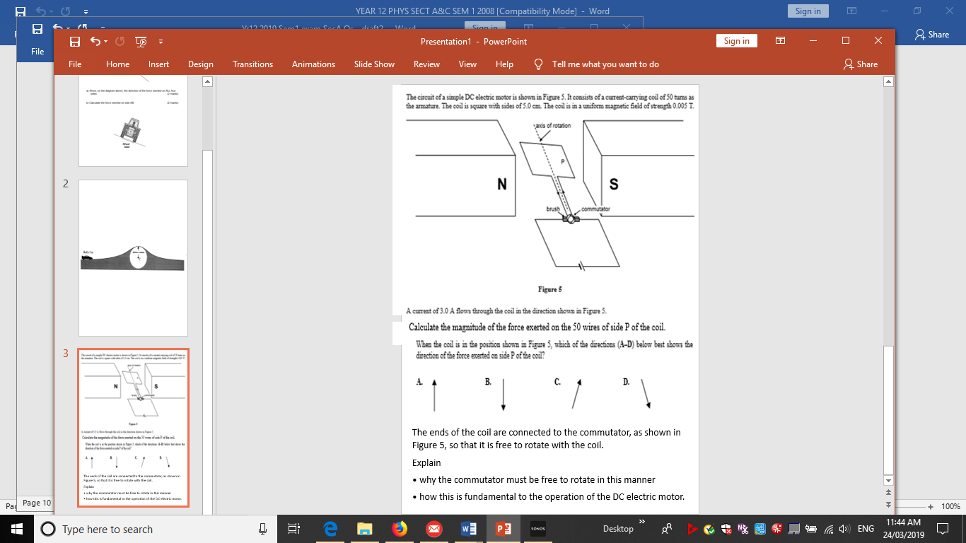

The circuit of a simple DC motor is shown in the figure opposite. It consists of a current-carrying coil of 50 turns as the armature. The coil is square with sides of 5.00 cm. The coil is in a uniform magnetic field of strength 5.00 mT. A current of 3.00 A flows through the coil in the direction shown in the diagram.

(a) Calculate the magnitude of the force on side P of the coil. (2 marks)

(b) When the coil is in the position shown in the diagram, which of the directions (A, B, C or D) best indicates the direction of the force exerted on side P? Circle the correct answer (1 mark)



(c) The ends of the coil are connected to a split-ring commutator, so that the coil is free to rotate. Explain why the split-ring commutator is fundamental to the operation of the DC electric motor. (3 marks)

**This page has been left blank deliberately.**

**Section Two: Problem-solving 50% (78 Marks)**

This section has **six (6)** questions. Answer **all** questions. Write your answers in the spaces provided.

Suggested working time: 90 minutes.

**Question 17 (10 marks)**

An eagle has captured a fish and is 14.7 m directly above the water when it releases the fish. The eagle is moving with a velocity of 5.20 ms-1 at an angle of 36.6o above the horizontal when the fish is released. Ignore air resistance for calculations.

36.6°

5.20 m s-1

14.7 m

This diagram is NOT to scale

(a) Calculate the time taken for the fish to reach the water. (4 marks)

(b) Calculate the horizontal distance that the fish travels during its flight back to the water.

(3 marks)

(c) Calculate the velocity of the fish when it hits the water. (3 marks)

**Question 18 (17 marks)**

The moons of Saturn are numerous and diverse – ranging from tiny ‘moonlets’ one kilometre across to the enormous Titan, which is larger than the planet Mercury. Saturn has 62 moons with confirmed orbits – 53 of which are named and only 13 have diameters larger than 50 kilometres. Data for two of the moons are provided below.

|  |  |  |  |  |
| --- | --- | --- | --- | --- |
| **NAME** | **DIAMETER**  **(km)** | **MASS (kg)** | **ORBITAL RADIUS (km)** | **ORBITAL PERIOD**  **(Earth days)** |
| **Mimas** | **396** | **4.00 x 1019** | **1.86 x 105** | **0.900** |
| **Dione** | **1123** | **1.10 x 1021** | **3.77 x 105** |  |

(a) The diagram below shows Saturn, approximate representations of the orbits of its two moons (Mimas and Dione), and the moons’ positions at a particular point in time.

On the diagram below, draw two vectors (arrows) that indicate the ***direction and strength*** of the gravitational field due to Saturn’s mass at the points indicated. Ignore any gravitational effects the moons’ masses may have on the other.

(2 marks)

**DIONE**

**MIMAS**

**SATURN**

(b) Using the data provided for Mimas and Dione in the table above – as well as Kepler’s Third Law - calculate the orbital period for Dione in Earth days. (4 marks)

(c) Use the data provided for Mimas to calculate the mass of Saturn. (4 marks)

(d) Which moon has the higher orbital speed - Mimas or Dione? Explain without calculating any values. (4 marks)

(e) NASA intends to insert a probe into an orbit around Saturn for scientific observations of its weather. Two students are discussing this probe; one student states: “All of the objects in this probe will be weightless because there are no forces acting on an object when it is in orbit.” Is this student correct? Explain your answer. (3 marks)

**This page has been left blank deliberately.**

**Question 19 (12 marks)**

A small object of mass 50.0 g is being rotated freely in a vertical circle of radius 1.50 m. It is attached to a string of the same length. At the position shown (i.e. the top of the vertical circle), the ***tension in the string is momentarily equal to zero***. The string is able to withstand a maximum tension of 2.50 N before it snaps.

object

Direction of motion

v = 1.00 ms-1

r = 1.50 m

X

Y

(a)Which of the arrows below best describes the direction of the object’s motion at point ‘X’?

(1 mark)

A: B: C: D:

**Answer: ________**

(b) Show via calculation that the object is travelling with a speed 3.83 ms-1 when it is at the top of the vertical circle. (3 marks)

(c) The object is rotating freely under the influence of gravity. Using your knowledge of the conservation of mechanical energy, calculate what its speed would be if it reached the bottom of the circle at point ‘Y’. (4 marks)

(d) Determine whether the string would snap before the object reaches Y’. Support your answer with a calculation.

[If you were unable to calculate an answer for part (c), use a value of 8.60 ms-1.]

(4 marks)

**QUESTION 20 (16 marks)**

A crane lifts 7.00 x 102 kg load of concrete on a building site. The 8.00 m crane arm is uniform and has a mass of 3.00 x 102 kg. The cable used to raise and lower the load is attached to the crane arm 6.00 m along the arm.

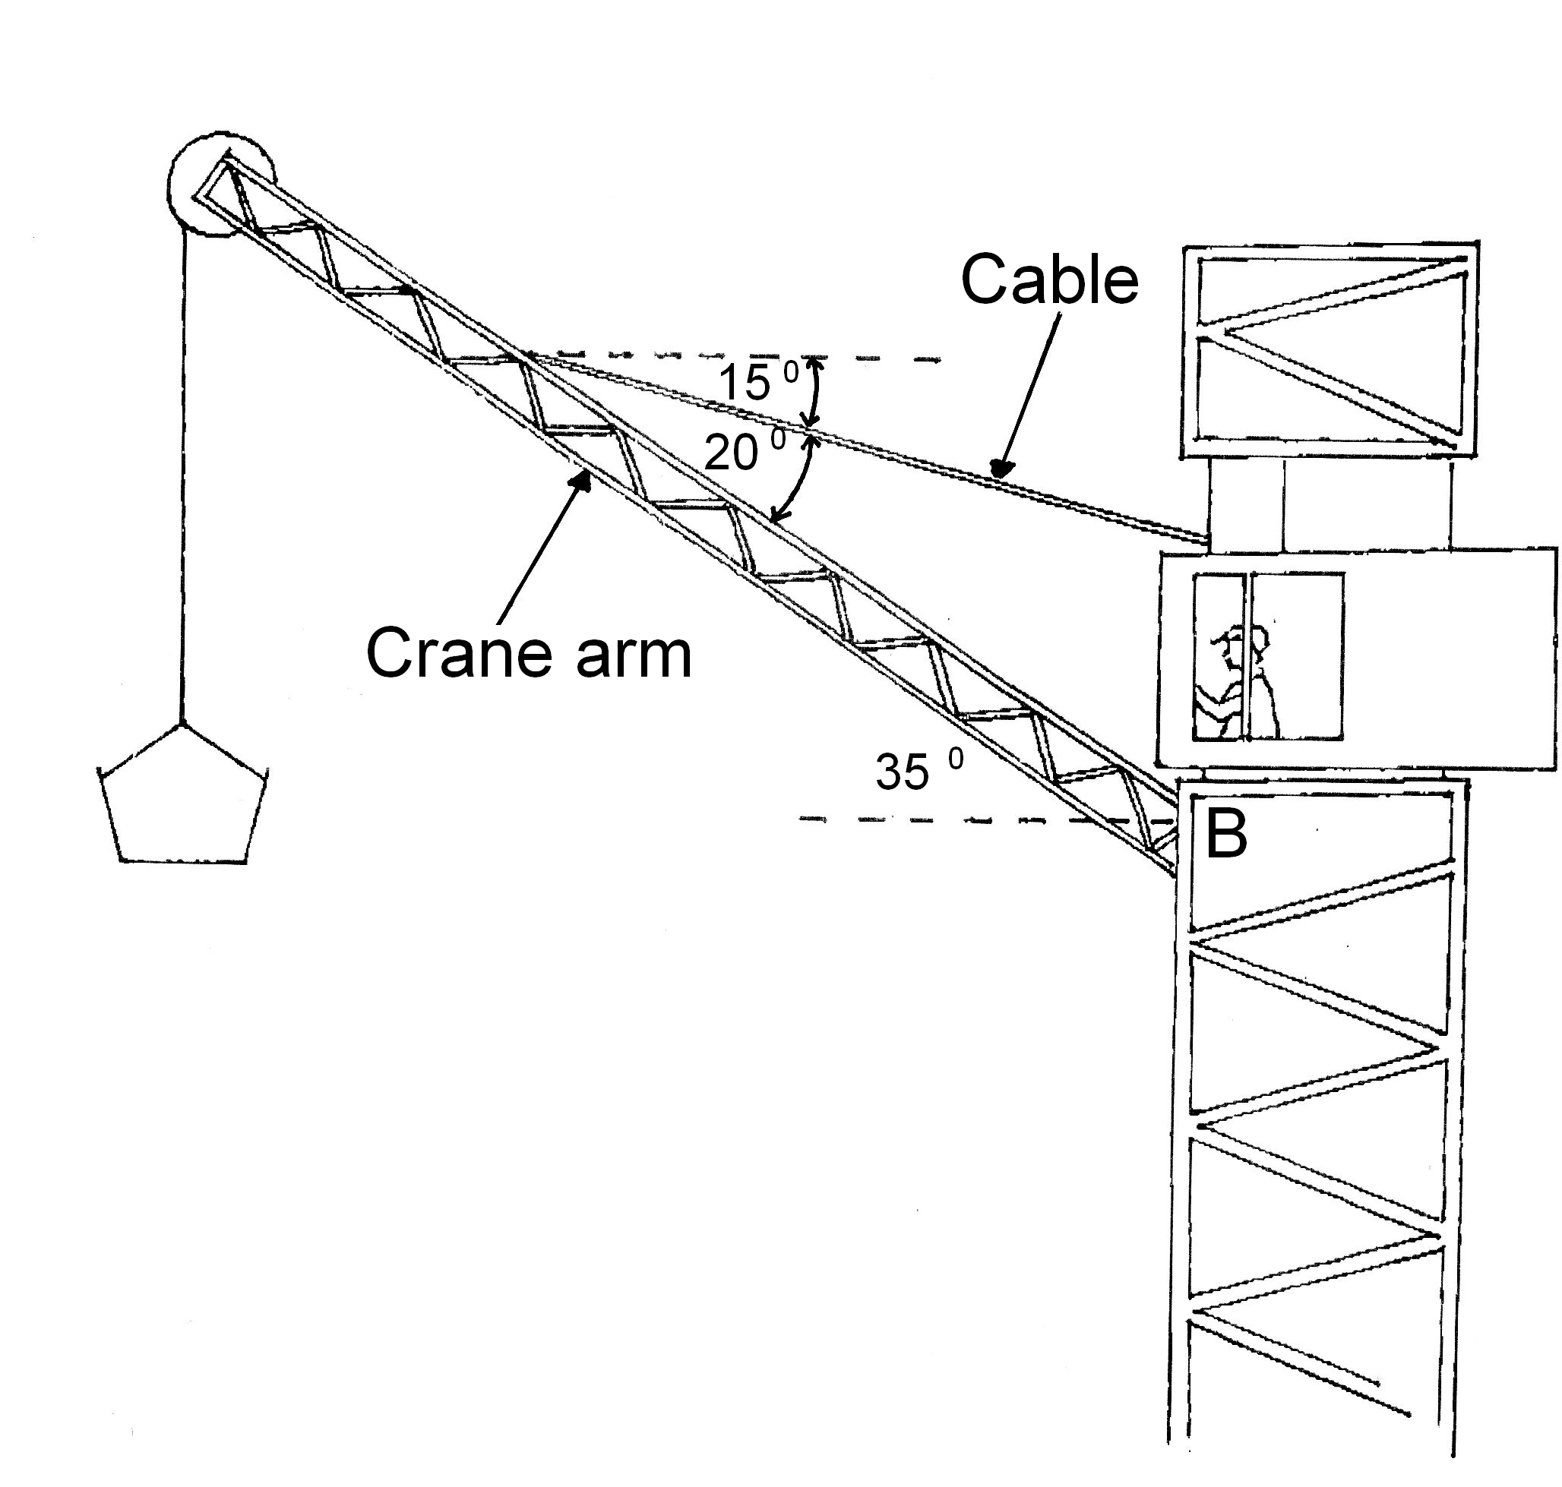

(a) On the diagram, draw the forces acting on the crane arm. (4 marks)

(b) Calculate the tension in the cable. (5 marks)

(c) Calculate the reaction force at the base of the crane arm (B). (4 marks)

(d) Describe what would happen to the ***magnitude and direction*** of the reaction force as the crane is lowered to a 30.0° angle to the horizontal. Justify your answer - no calculation is required. (3 marks)

**Question 21 (12 marks)**

The graph below shows how the torque on one (1) coil in an experimental DC motor varies over time.

**Torque (Nm)**

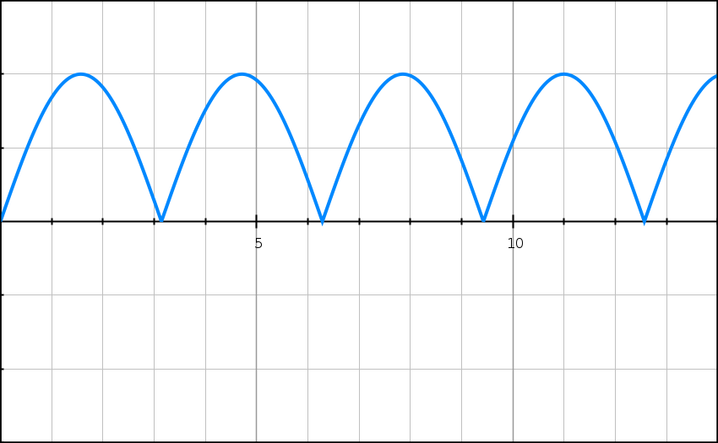

**0.00**

**Time (ms)**

**0.10**

**0.05**

**-0.05**

**-0.10**

(a) On the graph, mark one (1) point where:

(i) the coil would be parallel to the magnetic field. Label this point ‘X’. (1 mark)

(ii) the coil would be perpendicular to the magnetic field. Label this point ‘Y’. (1 mark)

(iii) Briefly explain your answer to part (i). A simple diagram should be included in your explanation. (2 marks)

(b) The shape of this graph suggests the presence of a commutator. Explain why the graph takes this shape, including a description of the commutator. (2 marks)

Some specifications for the coil and the DC motor are shown below:

• Current in coil (I) = 0.500 A

• Dimensions of coil (square shape): 20.0 cm x 20.0 cm

• Number of turns (N) = 20

(c) Using appropriate formulae from your Formulae and Constants Sheet, show that the maximum torque (max) generated by the coil can be derived by the following expression:

$$τ_{max}=IBAN$$

where ***B*** is equal to the magnetic field strength in the DC motor. (3 marks)

(d) Using the expression in part (c), the graph at the beginning of this question and the specifications of the DC motor, calculate the magnetic field strength B in the motor.

(3 marks)

**Question 22 (11 marks)**

Alpha particles (He2+) are doubly-charged positive ions and have a mass of 6.64 x 10-27 kg. They are accelerated through an electric field between charged parallel plates before entering a vacuum chamber where they are deflected by a magnetic field.

Alpha particles

Vacuum Chamber

Charged plates

Ion Accelerator

Deflection in magnetic field

Velocity Selector

(a) Calculate the potential difference between the charged plates in the ion accelerator that will give the alpha particles a maximum velocity of 3.40 × 105 ms-1. (3 marks)

(b) Between the ion accelerator and the vacuum chamber is a ***velocity selector***, which has an electric field and magnetic field at right angles to each other.

(i) On the diagram below, indicate the direction that the magnetic field must be to ensure the alpha particles maintain a horizontal path. (1 mark)

+ + + + + + + +

- - - - - - - - -

++

(ii) Use the formulas for the force on a charge in an electric and magnetic field to derive the relationship between E and B that gives the velocity of the particles. (2 marks)

(c) Indicate on the diagram at the top of page 26 the direction of the magnetic field within the vacuum chamber that will cause the deflection shown. (1 mark)

(d) The magnetic flux density within the chamber is set to 72.5 mT and causes the alpha particles to go into a uniform circular path. Calculate the period of revolution for the alpha particles. (4 marks)

**Section Three: Comprehension 20% (36 Marks)**

This section has two (2) questions. Write your answers in the spaces provided.

Spare pages are included at the end of this booklet. They can be used for planning your responses and/or as additional space if required to continue an answer.

Suggested working time: 40 minutes.

**Question 23 (20 marks)**

# http://www.newscientist.com/data/images/ns/cms/dn8927/dn8927-1_700.jpgNeutron star collisions create huge magnetic spikes

The strongest magnetic fields known in the universe are produced when a pair of extremely dense and compact stars merge. The first computational model has been devised of such an event that takes magnetism into account. The model begins with two cold neutron stars in a circular orbit around each other, both with masses 1.4 times that of the Sun. Comparative masses can be seen in Table 1.

When their orbits decay and the two stars collide, they merge to form a single object incredibly quickly - within about 2 milliseconds. Spiral arms then form off the central object and, at the point of intersection, instability causes the two stars' magnetic fields to curl into vortex rolls.

Previous work had suggested that merged neutron star remnants might collapse under their own weight to produce black holes before being able to produce a big magnetic spike. But the collapse is estimated to take at least 100 milliseconds, and the new data suggests an extremely short timescale for the amplification of the merged object's magnetic field, showing the spike should occur in reality.

|  |  |  |  |  |
| --- | --- | --- | --- | --- |
| Table 1: Comparative masses of known entities in the Universe. | | | | |
| **Object** |  | **Mass** | **Radius** |  |
| the sun |  | 1.99 × 1030 kg | 696,000 km |  |
| white dwarf star |  | 0.5 to 1.4 solar masses | 5000 km |  |
| neutron star |  | 1.4 to 3 solar masses | 10 km |  |
| stellar black hole |  | more than 3 solar masses | 2*Gm*/*c*2 (event horizon) |  |
| super massive black  hole |  | > 106 solar masses | 2*Gm*/*c*2  (event horizon) |  |
| the known universe |  | 1053 kg | 13.7 × 109 light years |  |

(Table adapted from http://hypertextbook.com/physics/matter/density/)

(a) Neutron stars are the remnants of huge stars that have exploded as supernovae. The neutron star mentioned in Paragraph 1 has a radius that is only of the order of 10 km. Such a dense object has very high gravitational field strength at its surface.

The density of an object is given by its mass divided by its volume:

$$\text{Density (ρ) = }\frac{\text{m}}{\text{V}}$$

(i) For a spherical star of average density ***ρ*** , the magnitude of ***g*** at its surface is given by:

$$\text{g =} \frac{\text{4}}{\text{3}}\text{Gπrρ}$$

where G is the universal gravitational constant.

Use these expressions to show that the units of ***g*** are Nkg-1 (3 marks)

(ii) The volume of a sphere is given by the expression: $\text{V = }\frac{\text{4}}{\text{3}}\text{π}{\text{r}}^{\text{3}}$.

Use this expression, the formula in part (i) and information in Table 1, to ***ESTIMATE*** the gravitational field strength at the surface of the neutron star. (5 marks)

(b) A remarkable property of neutron stars is that they spin about their axes at a very great rate. The radiation from these stars is observed as regular pulses. This gives rise to the name 'pulsars'. This particular neutron star of radius 10.0 km rotates 50.0 times every second.

(i) Show that the speed of a point on the equator of the star is approximately one percent (1%) of the speed of light. (3 marks)

(ii) Calculate the centripetal acceleration at a point on the equator of the star.

(3 marks)

Below is astronomical data that you may find useful when answering the following question.

|  |  |
| --- | --- |
| mass of Cassini = 2.20 x 103 kg | diameter of Saturn = 1.21 x 108 m |
| mass of Jupiter = 1.90 x 1027 kg | Saturn day = 10.7 Earth hours |
| mass of Saturn = 5.70 x 1026 kg |  |

(c) Calculate the magnitude of the total gravitational field strength experienced by Cassini when it is 3.90 x 1011 m from Saturn. (2 marks)

(d) The Earth has multiple satellites orbiting it at any point in time. The centripetal force required to keep the satellites in orbit is provided by the Earth's gravitational field. Use this fact to derive an expression for the orbital radius ***r*** for the satellite, let:

G = the gravitational force constant

r = the radius of orbit of the satellite

v = the speed of the satellite in its orbit

ME = the mass of the Earth

MS  = the mass of the satellite

(2 marks)

(e) A telecommunications satellite needs to be placed at a certain height above the surface of the Earth at the equator so that it remains in geosynchronous orbit. Calculate the orbital radius `of the satellite.

(2 marks)

**Question 24**  **(20 marks)**

**Determining the Magnetic Field Strength (B) of a Horse-shoe Magnet**

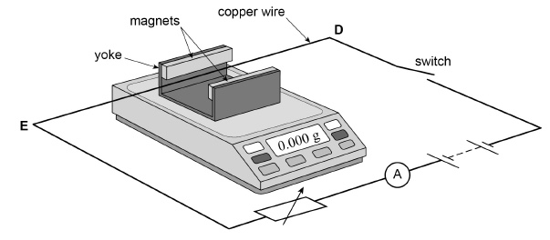



Students performed an experiment to calculate the magnetic field strength (***B***) of a horse-shoe magnet.

The equipment was set up as shown in the photograph. The diagram shows the configuration of the circuit. The horse-shoe magnet was placed on the mass balance and it was tared (set to read

0.00 g). The current-carrying conductor was stretched tightly and clamped in place such that it was unable to move.

The current through the conductor was varied and the reading on the mass balance noted. The results are displayed in the table below.

|  |  |  |
| --- | --- | --- |
| **Current (A)** | **Change in Mass (Δm) (g)** | **Force (N)** |
| 0.0 | 0.00 |  |
| 1.0 | 0.18 |  |
| 2.0 | 0.33 |  |
| 3.0 | 0.53 |  |
| 4.0 | 0.76 |  |
| 5.0 | 0.97 |  |

(a) The direction of conventional current in the photograph above is left to right. Annotate the north and south pole of the magnet on the photograph above. (1 mark)

(b) Explain using relevant mathematical relationships or formulae how this experimental setup can be used to calculate the magnitude of magnetic field strength of the horse-shoe magnet.

(2 marks)

(c) Complete the table above by filling in the values for force. (2 marks)

(d) The photograph is 50.0 % the size of the real equipment. Use the photograph, and this information, to measure the length of the conductor in the magnetic field. (1 mark)

Length of conductor in magnetic field = __________________

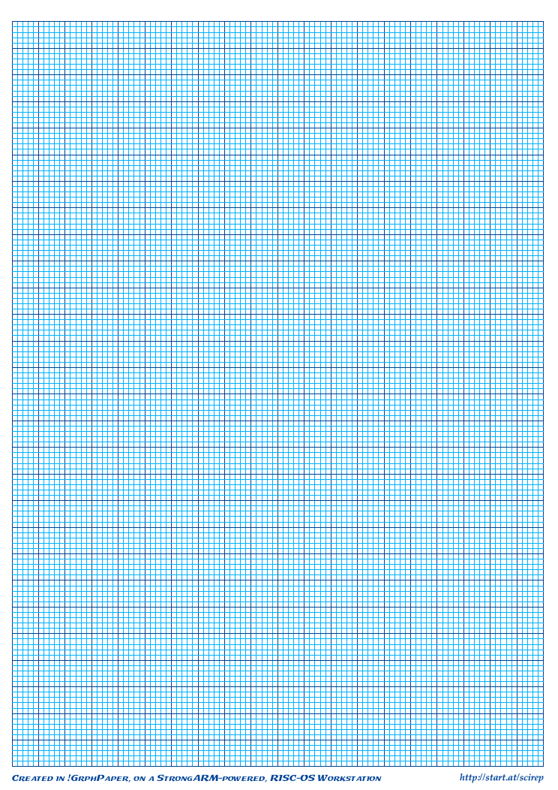

(e) Use the mathematical relationship you have described in part (b), and the information you calculated in (c), to draw a graph that will allow you to calculate the magnetic field strength of the horse-shoe magnet. Do not include error-bars. (4 marks)

(f) Use the graph to calculate the magnetic field strength of the horse shoe magnet. Clearly show all working. (4 marks)

(g) For the fourth data point only (balance reading = 0.53 g; current = 3.0 A), calculate the value for magnetic field strength and its associated uncertainty. (4 marks)

(h) Error bars should be included for all points on your graph; however, as they are very small, they are difficult to display accurately at graph scale.

For the fourth data point only (balance reading = 0.53 g; current = 3.0 A), display the error bar associated with this point only by drawing a ***magnified version of this point*** on the graph paper below. (2 marks)



**END OF EXAM**

Acknowledgements

Question 23 New Scientist, March 2006 by [Kimm Groshong](http://www.newscientist.com/search?rbauthors=Kimm+Groshong) ; Journal Reference: *Science* (DOI: 10.1126/science.1125201)

**EXTRA GRID**



**ADDITIONAL WORKING SPACE**

**ADDITIONAL WORKING SPACE**

**ADDITIONAL WORKING SPACE**

**ADDITIONAL WORKING SPACE**